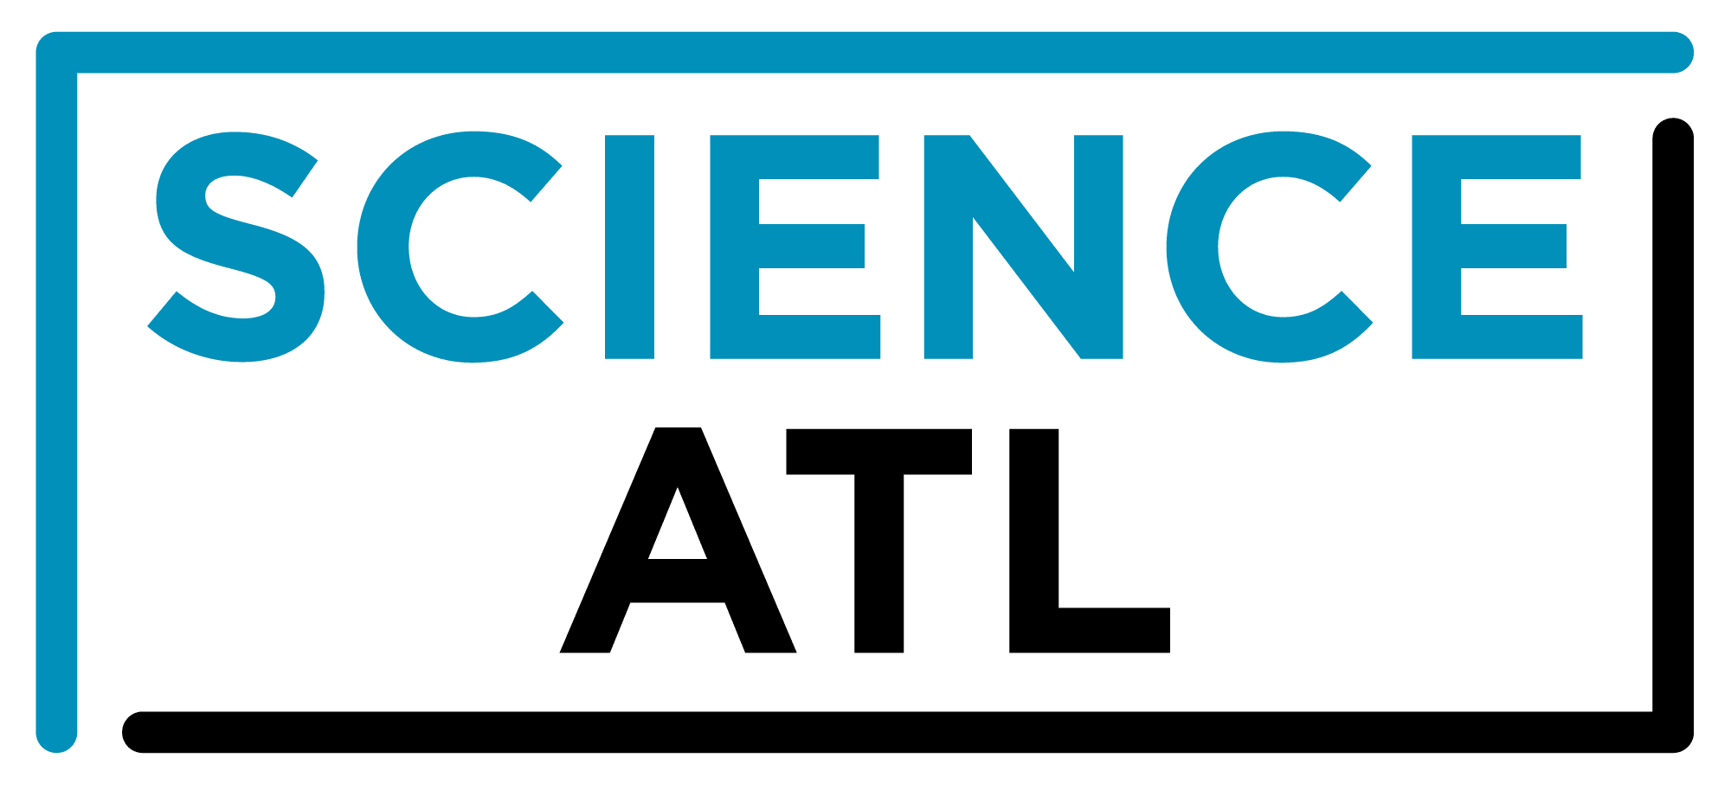
For Immediate Release:

Contact: Jon Waterhouse | Lenz, Inc.
678.770.9561
jwaterhouse@lenzmarketing.com

Science ATL and Emory University extend
partnership for five years
Emory’s sponsorship will help expand nonprofit’s community engagement, public events

August XX, 2022 (Atlanta) — Science ATL announced today it will continue its longstanding partnership with Emory University through 2027. Together, the two organizations will work to enhance public engagement with science and broaden access to science among underrepresented groups.

Emory has been a founding sponsor since Science ATL launched in 2014 with its annual event, the Atlanta Science Festival. Through its partnership with Emory, Science ATL has reached more than 300,000 people in metro Atlanta with engaging science learning experiences.

“Emory University has been a key partner since day one,” says Jordan Rose, executive co-director of Science ATL. “Their leadership in the community has catalyzed our work since 2014, and will now propel us forward as we promote Atlanta-based scientific discoveries, highlight diverse scientists and students, and connect youth and families to science learning opportunities.”

In this collaboration, Science ATL will continue building a community of lifelong learners who are connected to and inspired by science through two initiatives: science storytelling and public science events. As part of the science storytelling project, Science ATL will create content to promote scientific discoveries in Atlanta and highlight Black and Latino voices in STEM.

Science ATL’s monthly public science events will be enhanced by collaboration with Emory’s faculty and students. New interactive events will include a self-guided Discovery Walk tour of Emory’s campus, and other events highlighting the university’s scientific contributions.

“I am proud of Emory’s role in making Science ATL real and possible,” says Ravi V. Bellamkonda, provost and executive vice president for academic affairs at Emory University. “I think all humans are curious by nature. Science gives us one way to be curious about the world, and to explore it using an organized method and approach. Curious, scientifically informed citizens are critical for us to thrive as a free, democratic society in this technological age.”

To learn more about Science ATL visit scienceatl.org or call 770-322-4992.

Interviews are available upon request.

About Science ATL
Science ATL Inc. is a 501(c)(3) nonprofit organization dedicated to bringing people together through the wonder of science. Our mission is to cultivate an equitable community of lifelong learners across metro Atlanta who are connected and inspired by the wonder of science. Through public events like the Atlanta Science Festival, and community-building initiatives like the Georgia Chief Science Officers youth leadership program and the STEM Professional School Partnership program, we are improving access to STEM/STEAM learning opportunities and building community around science. Learn more at scienceatl.org.
###

